# Open Items Monthly Update

**Objective:**

To keep track of action items committed by Management

For Audit Committee and Group President to be updated on the progress

To avoid recurrence of findings/problem

**Guidelines:**

**When to give updates**

One (1) month after official release of audit report or 18th of the following month, whichever is later. Thereafter, until all the issues are closed, updates every 18th of the month should be sent to the same addressees.

**Who should provide update**

Personnel directly involved in the process, Supervisor, Manager, or Executives

**What to provide during update**

* Description of action taken or progress including assessment if will be done by committed target date; Modifications on the action plan etc.
* Supporting documents (report, memo, pictures)

**To whom it should be provided**

* All email correspondences should be sent to [internal.audit@lafilgroup.com](mailto:internal.audit@lafilgroup.com)
* For specific questions/clarifications, you may reach out to the team lead of the engagement:

**Audit Team* Team Lead**

Tech Baltazar T. Castrana Jr./Kathleen D. Villados

Ops Mnl Glaiza M. Macaspac

Ops Ilo Stella Mariedith B. Leda

*You can see these under the column “Audit Team” on tabs *2 - List_Ongoing* and   
*5 - List_Not Due* from the file sent every month.

**When is an action item considered closed**

* It will be closed after all supporting documents were provided and action done was verified.

**How to confirm supports provided are already enough for the items to be closed**

* Upon sending of update, internal.audit will send an email that a certain item is closed or will ask for other details or supports. Internal Audit will also verify on site.

**Procedure:**

Every month, IAD (using [internal.audit@lafilgroup.com](mailto:internal.audit@lafilgroup.com)) will send a summary based on updates received. This will be used as reference by Audit Client for the following month’s update. New action items from recently released reports will be coordinated by respective audit team. File sent will have 5 tabs:

1. Lead Ongoing – contains the count summary of open items.

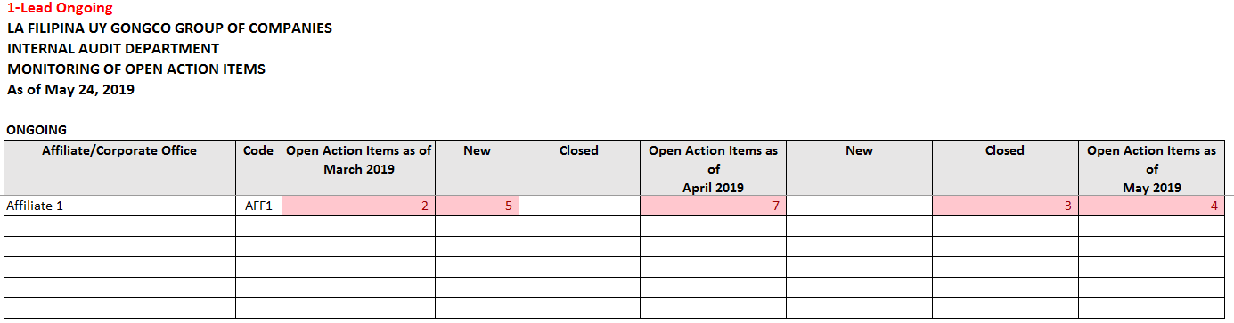

1. List Ongoing – Details of the Issue that has yet to be fully addressed

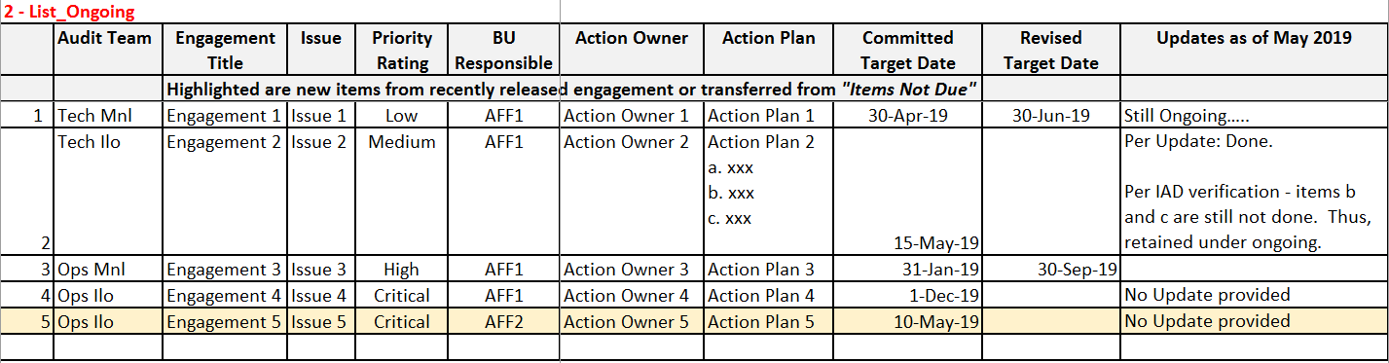

*Notes:*

1. *Due dates are based on Original Target Dates. Thus, even if Revised Target Date is after the Date of Update but Original Target Date already lapsed, it is still considered as Due.*
2. *All sub-items must be done for the whole action plan to be considered as Closed.*
3. 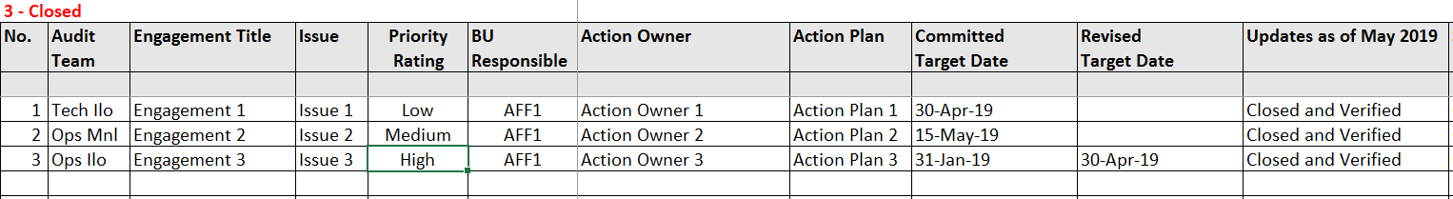Closed – closed items for the period (ie., April 19 to May 18, 2019)
4. Lead Not Due – contains the count summary of open items that are not yet due based on the Original Target Date

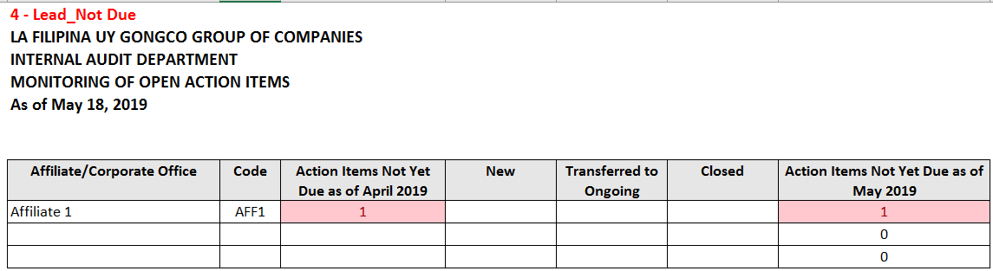

1. List Not Due – Details of the open items that are not yet due based on the Original Target Date

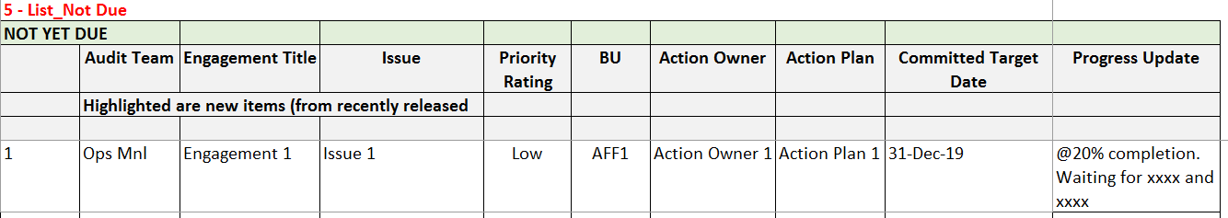

*Notes:*

1. *Update on progress is also needed*
2. *Items with elapsed Original Target Dates are transferred to List Ongoing tab.*